The 3rd Annual Peter Becker Christmas Parade
SUNDAY DECEMBER 11TH starting at 4:30 PM

WE ARE LOOKING FOR THE COMMUNITY’S PARTICIPATION IN THE PARADE

Please call or text Bonnie 518-903-0276, Mary Alice 518-728-5296, OR Sarah 518-573-1886 with any questions
__________________________
*Decorate a Float, ATV, Car, Truck, Tractor*
Use your Imagination!
Come Join Us!
PARADE WILL BEGIN IN EAST BERNE AND FOLLOW RT 443 TO END IN BERNE
Line Up will begin at approx. 3:30 PM *
_____________________________________________
Start: 4:30PM at Helderberg Blue Stone
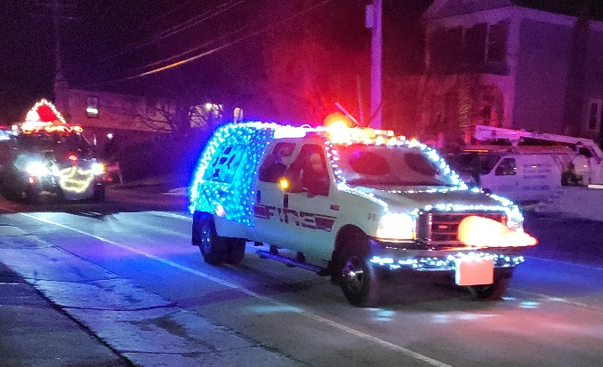
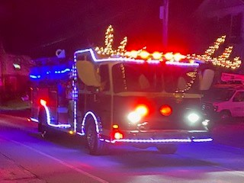
Finish: Berne Town Park

